Scheduled Stop and Start AWS ec2 instances

EC2:

Make sure ec2 has a specific tag name and key to identify by lambda.

In here we use Tag name: project and Key: test

IAM policy and role:

IAM user create and role set:

Create a policy with below JSON script:

IAM console > Policies > Create Policy > JSON

Then paste the json code to create a policy to allow ec2 and log permission.

Create a role and attached the new IAM policy with it.

IAM console > Roles > Create role > select lambda > add the new policy and create the role.

Add “AWSLambdaBasicExecutionRole” in the permission as well.

Lambda Function:

Create a 02 separate lambda function to start and stop instance with proper python code.

Lambda console > create function > Runtime: python 3.x

Then paste the start or stop code according to the function name.

Schedule creation:

Create 02 separate rules to start and stop instance with proper lambda function attached.

EventBridge console > Rules > create rule >

Below is start rule. Create another for stop rule.

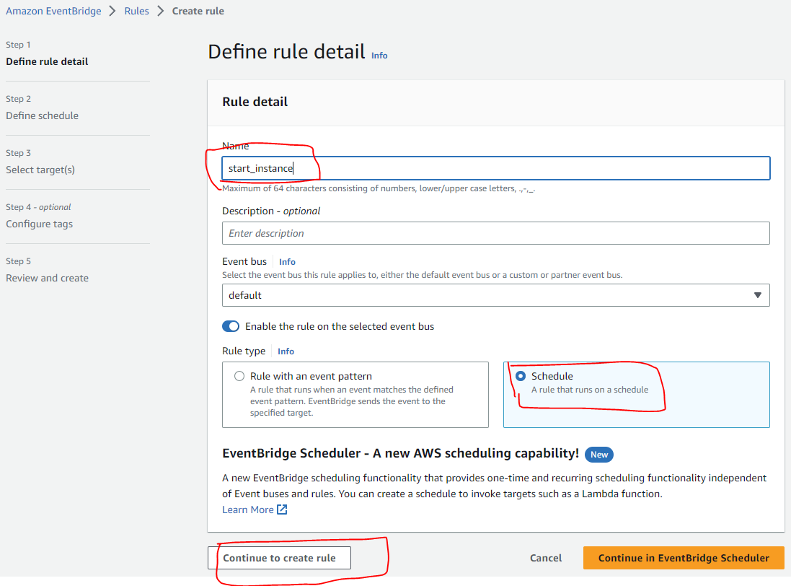

Set cron schedule to execute the function. below one will:

**Run at 04:00 am (UTC+0) every Monday through Friday.**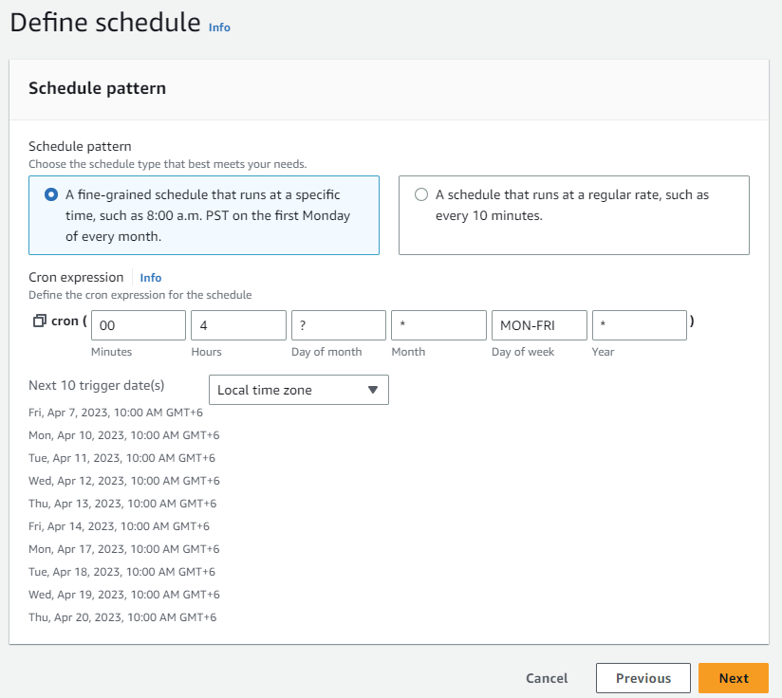

**Select target as Lambda_function and select the start function.**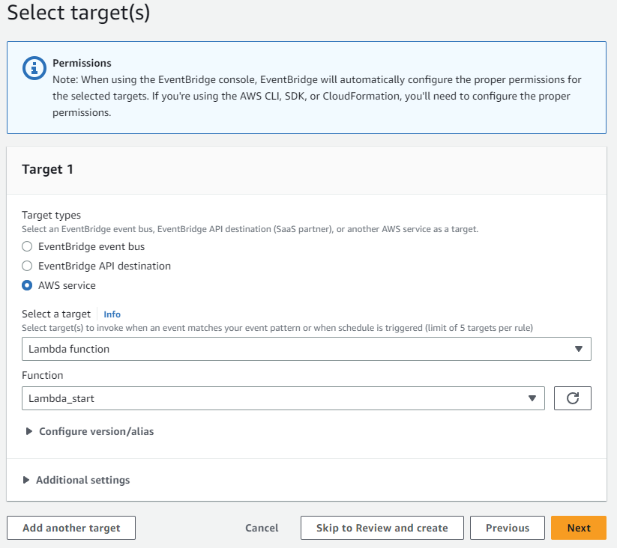

Then preview and create the rule.

Proper ec2 should be start on the schedule time.

**Check log from cloudwatch log.**

